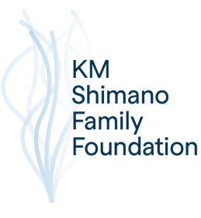

The KM Shimano Family Foundation

Donation Request Guidelines

The KM Shimano Family Foundation strives to make the world a better place through education, engagement, and conservation. We are currently focusing on marine environment conservation. This can encompass rescue and rehabilitation of marine mammals, scientific research of the oceanic environment, and legislative work.

Guidelines for applying to us for funding are outlined below. Proposals must follow the attached application format and include all specified information in the designated order to be considered. Incomplete proposals will not be returned or considered for funding.

The deadline for applications is July 1st of each year. Recipients will be announced by September 1st of that year. Any previous year’s grant must have had a completed Grant Reporting Form submitted by June 1st.
The KM Shimano Family Foundation
1055 Wisconsin Ave NW, Unit 3W
Washington, DC 20007

EIN: 87-3647912

Requests for endowments or multi-year donations will not be accepted. Recipients must reapply each year.

Grantmaking Guidelines

Focus:

The focus of our Foundation is to provide donations to organization that work in the following areas:

- Marine animal rescue & rehabilitation
- Marine animal research
- Marine animal conservation
- Water conservation (focus on salt and/or brackish)
- Marine education
- Environmental Conservation and Education
- Scientific Research in marine life health and conservation

Eligibility:
Please be aware of the following eligibility requirements:
- Must be a qualified 501(c)3 charity. Money will not be awarded to individuals.
- Previous recipients must be up to date with their reporting requirements.
- International charities are eligible; however, we would prefer to gift to international charities through an intermediary U.S. based charity.
- The request should come through someone who is personally involved with your charity and willing to stake their reputation on the charity.
- Operating costs of your proposed project must be less than 10 percent of the budget.

Evaluation:
Applications will be evaluated on the following criteria:
- Compatibility and alignment with our Mission
- Level of need
- Demonstrated impact
- Level of Detail

Application Process:
New applicants are encouraged to contact us with any questions prior to application. You may wish to email us with some information about your organization (ex. Website) prior to starting the process. A short narrative about you and your organization would be very helpful.

Inquiries may be sent to the address above or emailed to info@kmsff.org

Please feel free to attach additional pages if needed, or reference external information.

